HONG KONG INSTITUTE OF VOCATIONAL EDUCATION
Laboratory 9a: Python Web Framework

TASK:
1. With reference to the Flask Template in lecture note, create the following web app application.

- The following Rectangle Input Form is shown when user access http://localhost:5000
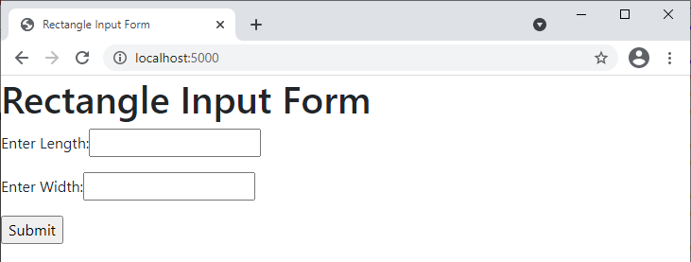

- When user input 1 in the length field, 2 in the width field, and click the submit button, the form redirects to a rectangle display page and length, width and area of the rectangle submitted before would be displayed. POST method should be used by the form to submit data
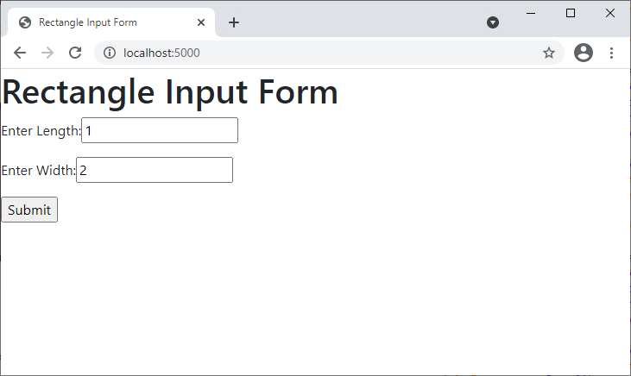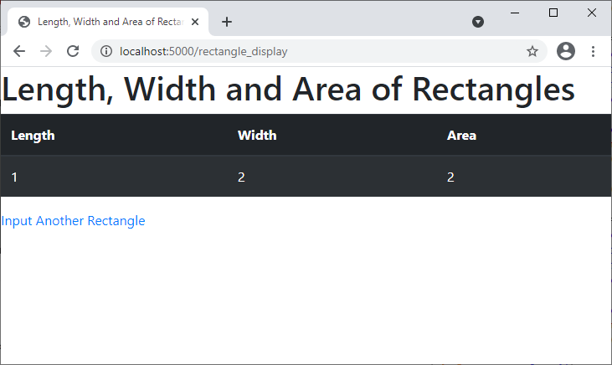

- Click on the link “Input Another Rectangle” under the table. You are allowed to input another rectangle. When user input 2 in the length field, 3 in the width field, and click the submit button this time, one more rectangle would be added to the table and its’ area, i.e. 6, would be calculated and displayed
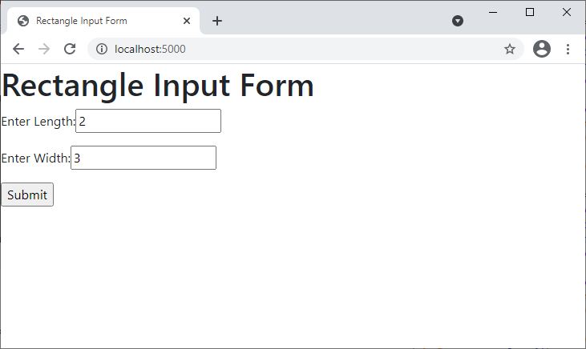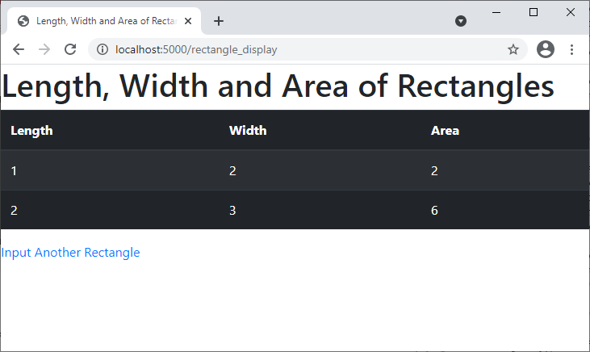

- Name your files using the following hierarchy.
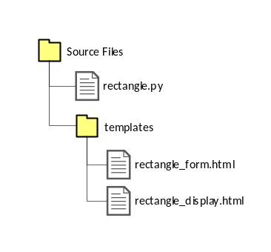
Answers: rectangle.py

from flask import Flask, render_template, request
class Rectangle :
def __init__( self, length, width ) :
self.__length = length
self.__width = width
def get_length( self ):
return self.__length
def get_width( self ) :
return self.__width
def find_area( self ) :
return self.__length * self.__width

list_rectangle = list()
list_rectangle.append( Rectangle( 1, 1 ) )
list_rectangle.append( Rectangle( 1, 2 ) )
list_rectangle.append( Rectangle( 2, 2 ) )
list_rectangle.append( Rectangle( 2, 3 ) )
list_rectangle.append( Rectangle( 3, 3 ) )

app = Flask( __name__ )

@app.route( '/' )
def index( ) :
return render_template( "rectangle_form.html" )

@app.route( '/rectangle_display', methods=["POST"] )
def rectangle_display( ) :
length = int( request.form[ 'length' ] )
width = int( request.form[ 'width' ] )
list_rectangle.append( Rectangle( length, width ) )
return render_template( 'rectangle_display.html', html_list = list_rectangle )

if __name__ == "__main__":
app.run()

Answers: rectangle_form.html
<html>
<head>
<!-- Required meta tags -->
<meta charset="utf-8">
<meta name="viewport" content="width=device-width, initial-scale=1, shrink-to-fit=no">
<!-- Bootstrap CSS -->
<link rel="stylesheet" href="https://maxcdn.bootstrapcdn.com/bootstrap/4.0.0/css/bootstrap.min.css" integrity="sha384-Gn5384xqQ1aoWXA+058RXPxPg6fy4IWvTNh0E263XmFcJlSAwiGgFAW/dAiS6JXm" crossorigin="anonymous">
<title>Rectangles Input Form</title>
</head>
<body>
<h1>Rectangle Input Form</h1>
<form action = "http://localhost:5000/rectangle_display" method = "post">
<p>Enter Length:<input type = "text" name = "length" /></p>
<p>Enter Width:<input type = "text" name = "width" /></p>
<p><input type = "submit" value = "Submit" /></p>
</form>
<!-- jQuery first, then Popper.js, then Bootstrap JS -->
<script src="https://code.jquery.com/jquery-3.2.1.slim.min.js" integrity="sha384-KJ3o2DKtIkvYIK3UENzmM7KCkRr/rE9/Qpg6aAZGJwFDMVNA/GpGFF93hXpG5KkN" crossorigin="anonymous"></script>
<script src="https://cdnjs.cloudflare.com/ajax/libs/popper.js/1.12.9/umd/popper.min.js" integrity="sha384-ApNbgh9B+Y1QKtv3Rn7W3mgPxhU9K/ScQsAP7hUibX39j7fakFPskvXusvfa0b4Q" crossorigin="anonymous"></script>
<script src="https://maxcdn.bootstrapcdn.com/bootstrap/4.0.0/js/bootstrap.min.js" integrity="sha384-JZR6Spejh4U02d8jOt6vLEHfe/JQGiRRSQQxSfFWpi1MquVdAyjUar5+76PVCmYl" crossorigin="anonymous"></script>
</body>
</html>

Answers: rectangle_display.html
<!doctype html>
<html lang="en">
<head>
<!-- Required meta tags -->
<meta charset="utf-8">
<meta name="viewport" content="width=device-width, initial-scale=1, shrink-to-fit=no">
<!-- Bootstrap CSS -->
<link rel="stylesheet" href="https://maxcdn.bootstrapcdn.com/bootstrap/4.0.0/css/bootstrap.min.css" integrity="sha384-Gn5384xqQ1aoWXA+058RXPxPg6fy4IWvTNh0E263XmFcJlSAwiGgFAW/dAiS6JXm" crossorigin="anonymous">
<title>Length, Width and Area of Rectangles</title>
</head>
<body>
<h1>Length, Width and Area of Rectangles</h1>
<table class="table table-striped table-dark table-hover">
<thead>
<tr>
<th scope="col">Length</th>
<th scope="col">Width</th>
<th scope="col">Area</th>
</tr>
</thead>
<tbody>
{% for i in html_list %}
<tr>
<td>{{ i.get_length() }}</td>
<td>{{ i.get_width() }}</td>
<td>{{ i.find_area() }}</td>
</tr>
{% endfor %}
</tbody>
</table>
<a href="http://localhost:5000">Input Another Rectangle</a>
<!-- jQuery first, then Popper.js, then Bootstrap JS -->
<script src="https://code.jquery.com/jquery-3.2.1.slim.min.js" integrity="sha384-KJ3o2DKtIkvYIK3UENzmM7KCkRr/rE9/Qpg6aAZGJwFDMVNA/GpGFF93hXpG5KkN" crossorigin="anonymous"></script>
<script src="https://cdnjs.cloudflare.com/ajax/libs/popper.js/1.12.9/umd/popper.min.js" integrity="sha384-ApNbgh9B+Y1QKtv3Rn7W3mgPxhU9K/ScQsAP7hUibX39j7fakFPskvXusvfa0b4Q" crossorigin="anonymous"></script>
<script src="https://maxcdn.bootstrapcdn.com/bootstrap/4.0.0/js/bootstrap.min.js" integrity="sha384-JZR6Spejh4U02d8jOt6vLEHfe/JQGiRRSQQxSfFWpi1MquVdAyjUar5+76PVCmYl" crossorigin="anonymous"></script>
</body>
</html>

